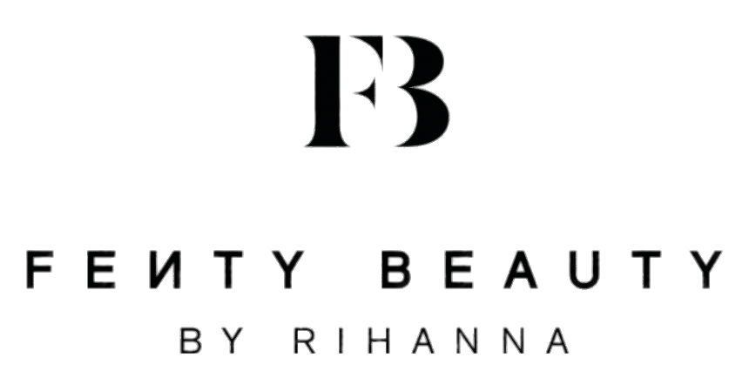

Data Analysis of the Cosmetics Usage of
Visually Impaired and Blind Consumers

USC Comprehensive Exam
Data Mining Report
Spring 2023
Brijea Daniel

Disclaimer: This work was completed as an academic project under the guidance of The University of Southern California. It is in no way affiliated with Fenty Beauty.

Data Analysis of the Cosmetics Usage of
Visually Impaired and Blind Consumers

Situation Analysis:
Singer and fashion icon Robyn ‘Rihanna’ Fenty created Fenty Beauty in 2017 after noticing a void in the industry for products that accommodated all skin types and shades. Fenty Beauty launched with over 50 shades of foundation, making history as the only cosmetics brand to have such an inclusive range of products. Since then, the Fenty empire has expanded to include skin products and even a lingerie line, all of them founded with inclusivity in mind.

Soon after, competing brands recognized the profit and opportunity in catering to all of its consumers. Now, it is commonplace for cosmetics brands to have a full range of shades. Fenty Beauty set the tone for diversity and inclusivity in the industry almost six years ago, but its positioning as the only inclusive cosmetics company is beginning to wane as others step up to the plate. Fenty Beauty has a unique opportunity to lead the industry once again by finding consumer groups that are still left out of the cosmetics conversation and making them feel seen and heard in Fenty Beauty marketing and products.

The following research suggests that visually impaired (VI) and blind consumers face barriers to beauty due to the over reliance on visual information in the industry and the common misconception that VI and blind consumers do not or cannot apply their own makeup.

Method:

Study 1:

In the first study, titled “It Feels Like Taking a Gamble”: Exploring Perceptions, Practices, and Challenges of Using Makeup and Cosmetics for People with Visual Impairments, researchers from Carnegie Mellon University used depth-first random sampling to find 145 YouTube videos relevant to the practices of VI people by searching vision-related key words and cosmetics phrases:

Searching Keywords
Blind Makeup, Blind Cosmetics, Blind Beauty, Blind GRWM, Blind Makeup Tutorial, Blind Beauty Step-by-step, Visually Impaired Makeup, Visually Impaired Beauty, Visually Impaired GRWM, Visually Impaired Makeup Tutorial, Vision impairment Makeup Tutorial, Low Vision Makeup

Researchers then excluded videos that were not related to cosmetics or did not feature VI or blind people (i.e., blindfolding videos were removed).

Video analysis included two steps: open-coding (sorting through data and categorizing it into codes based on properties and dimensional range) and affinity diagramming (organizing large amounts of data into groups based on themes or relationships to each other). From this method, the researchers generated four themes and 23 codes. The four themes include learning makeup, makeup selection and identification, makeup application, and self-assessment and feedback.

Following the video analysis, the researchers sent out a recruitment form via social media platforms to solicit volunteers for semi-structured interviews. Twelve volunteers participated in the Zoom interviews. All of them identified as female, all of them were either legally or totally blind, and their ages ranged from 20-48. The questioning procedure is included below:

“In the interview, we first inquired about participants’ demographic information and past experience with cosmetics, such as when and how they first started applying makeup, obstacles they encountered along the way, and how they dealt with them… We asked participants to discuss their perceptions of wearing makeup both for personal meanings and influence over social interactions (e.g., How does wearing makeup make you feel? What do you think is the role of makeup in society?). Furthermore, we asked participants to share their experiences and any challenges they encounter throughout the entire makeup routine, such as selecting and purchasing products (e.g., Where and how do you purchase makeup products?), learning or following specific practices (e.g., How do you learn makeup styles?), and checking and correcting a makeup look (e.g., How do you check your makeup after it's done?). Finally, we asked participants to describe how they experimented with new makeup, and how makeup could be used to help them express their creativity.”

Using the same methods as they did during the video analysis, the researchers pulled out six themes and 35 codes. The six themes include broader representations of blindness and beauty, relationship between makeup and self-image, relationship between makeup and social interaction, controlling visibility, community and belonging, and importance of support and motivation.

Study 2:
The second study, The Effect of Media and Beauty Standards on the Body Image of Women with a Visual Disability, sought to investigate the ways media influences women with visual disabilities. The study looked to local organizations that service the blind and found six female volunteers who were asked to complete a survey and in-depth interview. The study used convenience sampling, i.e., it included participants that were readily available, to source volunteers. Pseudonyms were used to maintain anonymity. Four of the volunteers were Black American women and two of them were Caucasian, all ranging in ages 18-30 and classified as legally or totally blind. The survey questions are included below (basic demographics portion excluded):
- Do you feel the media creates an unattainable body image for women? Can you tell me more about this? Do you know any of these women personally who have been influenced?
- Can you describe a few of your thoughts on African American beauty? Do you watch (or listen to) media (i.e., television, music, magazines, et.)?
  - In watching (or listening to) __, have you seen (or heard) advertisements focused on women’s “ideal” body, whether explicitly or implicitly?
  - What do you remember about the advertisement?
  - How did it make you feel?
  - Do you think the advertisement influences you in anyway (i.e., body image)
- Do you think you generally have a positive or negative sense of body image?
  - Who or what influences this sense of body image?
  - Are others’ opinions of your physical appearance important to you?
Growing up, has a family member/friend ever mentioned your body size?
- How did this make you feel?
- How old were you?
- What did they say?
- How often did they mention it?
- How has society influence your thoughts on your body image?
- Have you ever felt depressed or upset in anyway about your body?
  - Can you tell me more about this experience and your feelings?
Do you ever compare yourself to other women within the media?
    - If yes, which media has the most influence on you (i.e., magazines, film/television, internet, etc.)?
    - Who/What influences the comparisons in your immediate circle?

Have you ever changed yourself because of someone in the media?
- Who or what influenced this change?
- What did you change about yourself (i.e., hair, clothes, body size)? What steps did you take to enact this change? (i.e., diet, exercise, makeup)
- How did you feel after this change? More like yourself or less like yourself? Happier/more fulfilled or less fulfilled?
- Were you committed to this change or did you revert back to how you were before?
- How does this consistency/non-consistency make you feel?
- How do you feel your personal experiences differ from that of other groups? Is there anything more you would like to add?

Results Summary:

Study 1:

Learning Barriers:

Participants cited a lack of resources and descriptive data in tutorials and makeup videos. Often, the subjects in tutorials assume that their audience is able bodied, resulting in a lot of demonstrative pronouns (i.e., ‘this,’ ‘that’) that make it hard for VI and blind audiences to keep track of what is being discussed. In the same vein, product instructions are made for seeing consumers. Participants mentioned that it would be nice if instructions were available for the blind as well.

Product descriptions themselves lack the proper color information required to identify the shade (for example, the color ‘moonlight’ for eye shadow is non-descriptive and unhelpful). Eyeliner and mascara are particularly challenging products because they are not built with VI and blind people in mind. Participants also mentioned difficulty sourcing feedback on their makeup looks and wished for an automatic system for critique.

Physical Barriers:

Each participant mentioned inaccessible product design. Mainstream makeup products have no tactile learning accommodations, meaning VI and blind people often have to feel the shape of each product to identify it. One participant suggested QR codes as an easy fix for information processing, but that technology-free solutions were preferable in the case of tech failure.

Shopping online for products proved to be an additional barrier because tech systems for the blind find it difficult to sift through the overload of photos and ads that accompany each product listing. However, shopping for products in person is a barrier within itself because the products are often too close, locked away, or lack tactile information for easy purchasing.

Study 2:

The second study’s results were more focused on VI and blind people’s perception of themselves in relation to beauty standards. A common misconception is that this community faces less pressure to conform because they cannot physically see themselves. The second study indicates that is false. Each woman agreed that the media sets up a harsh standard for women to conform to and agreed that they felt scrutinized in some shape or form as a woman in today’s society. The Black women in the study mentioned culturally specific standards that they felt were unrealistic, like the Coke bottle shape or negative representations of Black women in the media.

While each participant emphasized that they had a positive self-image, each one mentioned feeling depressed about some aspect of their body. Many of the women had received negative comments about their weight or body size that influenced the way they felt about their own bodies.

Lastly, half of the women specifically mentioned overcoming obstacles and challenges in environments structured for able-bodied people. The overwhelming ignorance of what it’s like to navigate the world as VI or blind person makes it harder for them to exist in society. They each cited pressure to look presentable in public because they feared they would be seen as incapable of completing mundane tasks if their appearance was not conventionally acceptable.

Implications:

Both studies emphasize a need for the inclusion of VI and blind people into the cosmetics space. The first study shows a robust number of opportunities for Fenty Beauty to provide accommodations to its products and websites to show VI and blind people that they are top of mind in the creations of Fenty Beauty products. Based off this study, Fenty Beauty can create informational makeup content that is accessible to the blind community, create product tools and packaging with proper descriptions and tactile tools, and craft a better website flow for easy navigation for VI and blind consumers. These are all relatively easy ways to include this demographic and set the pace for inclusivity in the industry.

The second study shows that VI and blind women are just as impacted, if not moreso, by the media’s portrayal of women as able-bodied women. They have the same desires to feel represented and acknowledged in a society that callously disregards their daily obstacles. In the second study, the researcher cites another study that calls to attention the reasoning for why disabled people are commonly left out of fashion and cosmetic marketing:

“To put it differently, fashion and cosmetic industries tend not to use disabled bodies promising to transform the body as an instrument of self-improvement… The beauty of people with a disability are rarely recognized and are almost never portrayed as sexual. This ultimately draws a gap between the able-bodied and the non-able-bodied.”

These findings present an opportunity for Fenty Beauty to include VI and blind people as models, makeup artists, and influencers for the brand in the same way it uses those without disabilities. Not only is there a market for it, but it would also further cement and propel the brand into being the leading, innovative brand in inclusivity.

Conclusion:

Fenty Beauty has led the industry time and time again inclusivity by creating products and messaging with marginalized communities in mind. To maintain its position as the leading brand in inclusivity, it should continue to break barriers and set the tone for what it means to be inclusive by continuously accommodating those who face barriers to cosmetics. Fenty Beauty has a unique opportunity to gain a loyal fanbase in the VI and blind community by making simple changes to its product design and messaging.

References:
Mingzhe Li, F., Spektor, F., & Xia, M. (2022, April). “It Feels Like Taking a Gamble”: Exploring Perceptions, Practices, and Challenges of Using Makeup and Cosmetics for People with Visual Impairments. ACM Digital Library. Retrieved April 17, 2023, from https://dl.acm.org/doi/fullHtml/10.1145/3491102.3517490
Robertson, T. (2019). The Effect of Media and Beauty Standards on the Body Image of Women with a Visual Disability. NC Docks. Retrieved April 17, 2023, from https://libres.uncg.edu/ir/uncg/f/Robertson_uncg_0154M_12856.pdf

